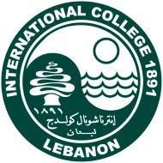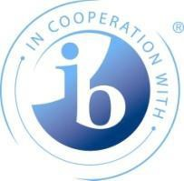

International College
In cooperation with the International Baccalaureate Organization
offers

IB Workshops:

Making the PYP Happen in the Early Years: Implementing Agency – Cat 1 (English)
PYP – Your Exhibition – Cat 2 (English)

Business Management – DP - Cat 2 (English) TOK for Subject Teachers- DP – Cat 3 (English)

Friday, September 2 – Saturday, September 3, 2022

Registration opens: May 24, 2022
Registration closes: August 12, 2022

Workshop Venue International College Bliss Street
Beirut, Lebanon Tel: +961-1-364016
Fax: +961-1-361448
Email: zdayya@ic.edu.lb www.ic.edu.lb

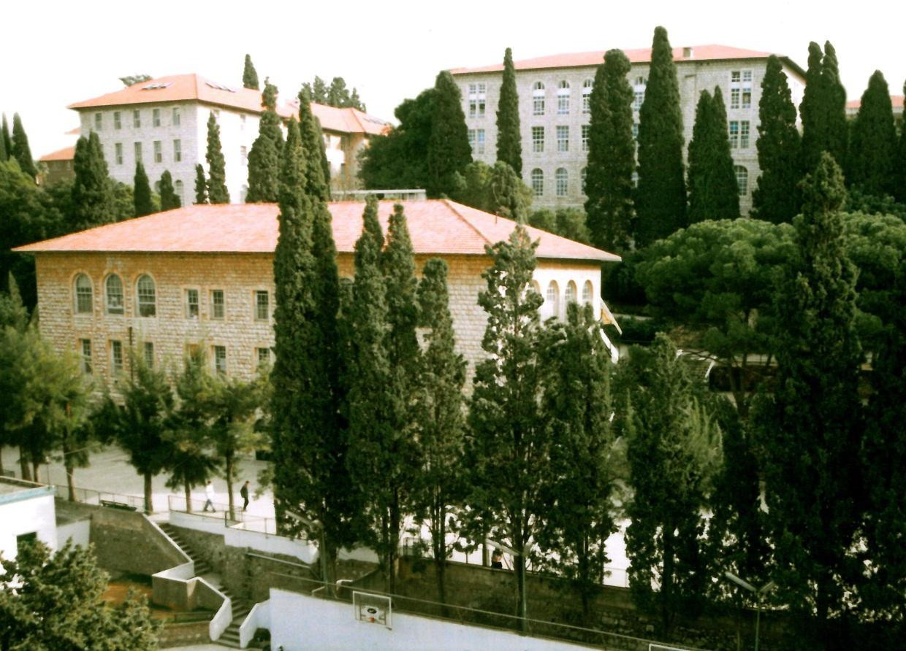

Details of the workshops

Category 1 Workshop

Making the PYP Happen in the Early Years: Implementing Agency

Recommended Audience:

All Primary Years Programme (PYP) teachers (early years, Primary Years, new to PYP and with some experience of the PYP).

Purpose of the Workshop
This workshop invites you to inquire into your own teaching practices and reflect on how you can develop the capabilities of a PYP teacher. By exploring the PYP framework, you will connect how voice, choice and ownership is recognized and developed in all members of the IB community. You will be supported in your understanding of learning and teaching in a transdisciplinary, concept-driven curriculum and how to design this in your own school context
NB: Prior to the training, you might be contacted to bring any required material for the workshop.

PYP – Your Exhibition (English)

Recommended Audience:

Experienced Primary Years Programme (PYP) teachers, coordinators and school leaders.

Purpose of the Workshop

This workshop engages you in an inquiry into the varied purposes and practices of your exhibition. Develop your understanding of the agentic role students have in leading and taking action on their learning. Explore, create and share a range of tools and strategies which help optimize the experience for students in the PYP and that set the scene for a collaborative inquiry into issues of local, national and global significance.

NB: Prior to the training, you might be contacted to bring any required material for the workshop.

DP - Business Management (English)
Recommended Audience:

Diploma Programme (DP) subject teachers who have prepared students for at least on DE exam session.

Purpose of the Workshop

This workshop is designed for participants who are keen to improve the teaching and learning experience in the DP classroom. The workshop will focus on:
- Assessing the links between IB Programme standards and practices to enhance the teaching and learning experience
- Reviewing aspects of assessment to ensure that teaching and learning activities promote student achievement and address subject-specific assessment criteria, both internal and external
- Integrating the IB philosophy, theory of knowledge (TOK) and creativity, activity service (CAS) to promote student understanding
- The role of the extended essay supervisor and subject-specific assessment criteria
This workshop will enable participants to:
- Create teaching and learning strategies that develop self-regulated and metacognitive learners
- Design appropriate inquiry-based lessons and activities for their subject
- Make connections between programme frameworks and classroom practice
- Enhance your understanding of assessment in IB programmes
- Discuss and analyse standards and practices

NB: Prior to the training, you might be contacted to bring any required material for the workshop.

DP - TOK for Subject Teachers (English)

Recommended Audience:

Experienced IB subject teachers who do not teach theory of knowledge (TOK) but would like to develop their understanding of TOK so that they may model and reinforce effective thinking skills and concepts in their teaching.

Purpose of the Workshop

During the workshop, you will have an opportunity to discuss the nature of the TOK. Through workshop activities, you will model the TOK approach by reflecting on yourself – the teacher – as “knowers” and discuss the “ways of knowing” in TOK and their relevance with other IB subjects. The workshop will explore the link between TOK and inquiry so that you can incorporate a practical understanding of TOK in quality curriculum planning and classroom teaching.

NB: Prior to the training, you might be contacted to bring any required material for the workshop.

General Schedule for IB workshops
Friday, September 2

8:00 – 10:30 | Session 1
10:30 – 11:00 | Refreshment break
11:00 – 13:30 | Session 2
13:30 – 14:00 | Lunch
14:00 – 16:30 | Session 3

Saturday, September 3

8:00 – 10:30 | Session 1
10:30 – 11:00 | Refreshment break
11:00 – 13:30 | Session 2
13:30 – 14:00 | Lunch
14:00 – 16:30 | Session 3

NB: Participants who attend all sessions of the workshop will receive a certificate of attendance.

Making the PYP Happen in the Early Years: Implementing Agency (English)

Hosted by International College Beirut – Lebanon
Friday, September 2 – Saturday, September 3, 2022

REGISTRATION FORM
This form should be faxed to Zeina Dayya at +961-1-361448 or emailed to the following address: erc@ic.edu.lb

School:

Address:

Tel No.: Fax No.:

Contact email:

Current School status:
DP authorized PYP authorized DP candidate PYP candidate Non IB school

IB School code:

Participant(s) | Position(s) | Participant’s email

Registration fee per person: $600 Total fee due : $
The registration fee includes:
  - Tuition
  - Workshop materials
  - 2 lunches - 2 snacks
  - Bottled water and coffee during workshops

PYP – Your Exhibition (English)
Hosted by International College Beirut – Lebanon
Friday, September 2 – Saturday, September 3, 2022

REGISTRATION FORM
This form should be faxed to Zeina Dayya at +961-1-361448 or emailed to the following address: erc@ic.edu.lb

School:

Address:

Tel No.: Fax No.:

Contact email:

Current School status:
DP authorized PYP authorized DP candidate PYP candidate Non IB school

IB School code:

Participant(s) | Position(s) | Participant’s email

Registration fee per person: $600 Total fee due : $
The registration fee includes:
  - Tuition
  - Workshop materials
  - 2 snacks
  - 2 lunches
  - Bottled water and coffee during workshops

Business Management - DP (English)
Hosted by International College Beirut – Lebanon
Friday, September 2 – Saturday, September 3, 2022

REGISTRATION FORM
This form should be faxed to Zeina Dayya at +961-1-361448 or emailed to the following address: erc@ic.edu.lb

School: Address:
Tel No.: Fax No.:

Contact email:

Current School status:
DP authorized PYP authorized DP candidate PYP candidate Non IB school

IB School code:

Participant(s) | Position(s) | Participant’s email

Registration fee per person: $600 Total fee due : $
The registration fee includes:
  - Tuition
  - Workshop materials
  - 2 snacks
  - 2 lunches
  - Bottled water and coffee during workshops

TOK for Subject Teachers – DP (English)
Hosted by International College Beirut – Lebanon
Friday, September 2 – Saturday, September 3, 2022

REGISTRATION FORM
This form should be faxed to Zeina Dayya at +961-1-361448 or emailed to the following address: erc@ic.edu.lb

School:

Address:

Tel No.: Fax No.:

Contact email:

Current School status:
DP authorized PYP authorized DP candidate PYP candidate Non IB school

IB School code:

Participant(s) | Position(s) | Participant’s email

Registration fee per person: $600 Total fee due : $
The registration fee includes:
  - Tuition
  - Workshop materials
  - 2 lunches - 2 snacks
  - Bottled water and coffee during workshops

Mode of Payment
For payment of fees, kindly contact the Educational Resources Center at: Tel: +9611364016
Email: erc@ic.edu.lb

Registration and Cancellation Policies

Registration will be confirmed only upon receipt of payment.
Participants should not make any travel or hotel arrangements until their registration has been paid for and confirmed in writing.

International College reserves the right to cancel any workshop if sufficient bookings are not received (and paid for) at least 3 weeks prior to the workshop starting day. If IC cancels any workshop, registered participants are entitled to a full fee refund.

If a registered participant decides to cancel the registration, IC must be advised by email to erc@ic.edu.lb by Thursday, August 12, 2022.
Cancellations received after August 12 will be charged the full workshop package. “No shows” at the workshop will also be charged the full workshop package.

Accommodation

Participants are responsible for making their own accommodation arrangements.

Participants must settle accommodation bills directly with the hotel. IC does not handle payment for hotel bookings. When making the hotel reservation, please mention the IC Conference to benefit from the special rate.

In the case of cancellation, the cancellation policy of the chosen hotel will apply.

All the hotels listed below are fifteen minutes away from Beirut International Airport.

Mayflower Hotel **** Yafet Street, Hamra Beirut-Lebanon
P.O. Box: 113 5304 Tel: + 961-1-340680 Fax:+ 961-1-342038
E-mail: res@mayflowerbeirut.com Website: www.mayflowerbeirut.com

The hotel's central location is convenient for walking around the city. It is also a five-minute walk to International College on Bliss Street. For more information, please check the hotel’s website.

Single room : $55/night Double room: $60/night
Rates are inclusive of Breakfast, WiFi, V.A.T. and service charges.

Crown Plaza Beirut *****
Hamra Street, Beirut, Lebanon, P.O. Box 113-7512 P.O.Box: 113-7512
Beirut - Lebanon
Phone: 961- 1- 754 755 / 755 754
Fax 961- 1- 749 555
Contact person: Ms. Cynthia Moutrane E-mail: Cynthia.Moutrane@ihg.com
Website: www.cpbeirut.com

The Crown Plaza Beirut is located in Hamra which is a main shopping area in Beirut. The hotel is a 7-minute walk to International College.
For more information, please check the hotel’s website

Deluxe Single room: $90/night Deluxe Double room: $100/night
Rates are inclusive of buffet breakfast but are subject to 11% VAT (Government tax).

Hotel Accommodation Booking Form

IB Workshops

Hosted by International College September 2 – 3, 2022

Name:

School:

Address:

Telephone/Office: Fax:
Mobile Phone: Email:

Single room Double room

Sharing with:

Smoking Non Smoking

Arrival date: Departure date:

Number of nights:

Credit Card details

Credit card type: Card Number: Expiration date: Name on the card:

Date: Signature:

Please fax this form to the hotel of your choice.

General information
Visa
Please check visa requirements with the appropriate embassy or consulate, or with a travel agency.

IC can provide a visa support letter upon request for participants whose registration has been confirmed.

Climate
Lebanon’s climate in September is mild. We suggest you check weather forecasts nearer the date of the conference.

